Automate the below use case using BDD concepts, Java and Selenium. Upload the code in the public GitHub and share the link. Ensure the following is included in your submission:

1. Create a Feature file
2. Write Java methods
3. Code should be executable
4. Generate cucumber report with screenshots

Use Case –

1. Launch the URL – <https://www.dbs.com.sg/index/default.page>
2. Click on Learn More button.
3. Scroll down and navigate to Singapore on the left panel.
4. Read and write the table in excel sheet.

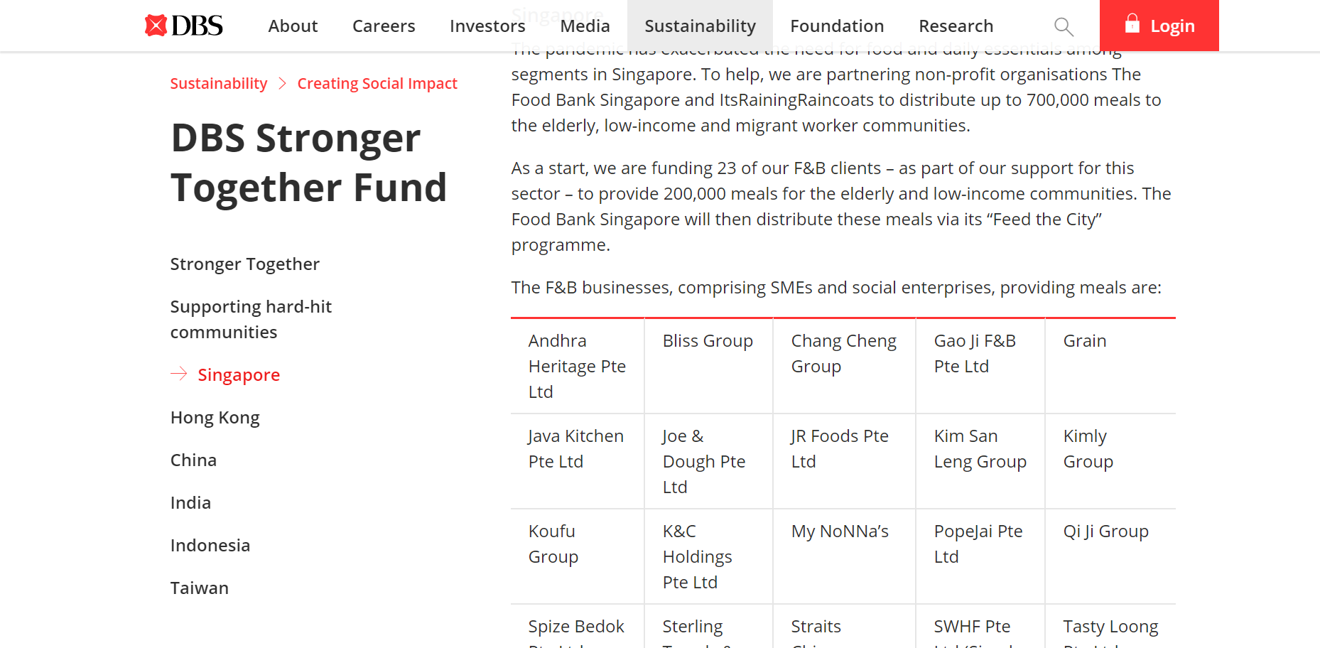

1. Navigate to **About** in the header tabs.
2. Navigate to **Who we are** tab.
3. Navigate to **Our** **Awards & Accolades**.
4. Validate the total number of awards displayed on the page is 22.
5. Validate all the award name and caption of the awards mentioned in the below table and print in the cucumber report in the form of a table.

|  |  |
| --- | --- |
| **Award Name** | **Caption of the award** |
| A World First | Euromoney |
| The Banker | Bank of the Year 2018 |
| Global Finance | Best Bank in the World 2018 |
| Euromoney | Awards For Excellence |
| Global Finance | World's Best Banks |
| Global Finance | World's Best Investment Banks and Derivatives Providers |